**Handwriting Analysis**



**MAJOR PROJECT REPORT**

*Report submitted in partial fulfillment of the requirements for the award of degree of*

***BACHELOR OF TECHNOLOGY***

***in***

***COMPUTER SCIENCE & TECHNOLOGY***

***by***

GOURAV KUMAR SHAW (2020CSB010)

SOUMYADEEP SINHA (2020CSB044)

*Under Supervision of*

***Dr. Samit Biswas***

*Assistant Professor*

*Indian Institute of Engineering Science & Technology, Shibpur*

**CERTIFICATE**

I hereby recommend that the Major Project report entitled **“Handwriting Analysis”** submitted by Gourav Kumar Shaw and Soumyadeep Sinhaunder my guidance and supervision(s), in partial fulfilment of the requirements for the degree in Bachelor of Technology in the department of Computer Science and Technology under Indian Institute of Engineering Science and Technology (IIEST), Shibpur.

Supervisor

________________________

**Dr. Samit Biswas**

Department of CST,

IIEST, Shibpur

**ACKNOWLEDGEMENT**

We extend our deepest gratitude and appreciation to **Dr. Samit Biswas** for granting us the invaluable opportunity to undertake this Major Project. His guidance, expertise, and unwavering support throughout this semester have played a pivotal role in shaping our understanding of deep learning and its practical applications.

We also extend heartfelt thanks to **Mr. Piyush Kanti Samanta** from the **Department of CST, IIEST Shibpur**, for his invaluable assistance and support during this endeavor.

Furthermore, we express sincere appreciation to **Dr. Apurba Sarkar,** Head of the Department (HoD) of Computer Science and Technology, IIEST Shibpur, for providing us with the opportunity to utilize the departmental lab facilities during our project work.

Finally, we would like to express our heartfelt gratitude to our family and friends for their constant support, encouragement, and understanding throughout this journey. Their unwavering belief in our abilities has been a constant source of inspiration and motivation.

**INDEX**

Abstract ……………………………………………. 05

Introduction ………………………………………… 06

Problem Statement…………………………………...07

Datasets Details………………………………………07

Data Collection………………………………………08

Proposed Methodology………………………………09

Model Architecture…………………………………. 12

Optimization………………………………………....13

Framework…………………………………………...13

Experimental Results…………………………...……14

Applications………………………………………….15

Conclusion……………………………………...……15

Future Directions………………………………….…16

References……………………………………………17

**Abstract :**

Handwriting analysis has been a subject of interest across various domains, from forensic science to document authentication. In this project, we leverage Convolutional Neural Networks (CNN), a deep learning technique, to discern the authorship of handwritten samples within a dataset. Our methodology involves training the CNN model on a labeled dataset of handwritten samples, enabling it to learn distinctive features and patterns unique to individual authors' handwriting styles.

Through rigorous experimentation and optimization, we have achieved a remarkable accuracy rate of 94% in identifying the authors of handwritten documents. This high level of accuracy underscores the effectiveness of our approach in accurately attributing handwritten samples to their respective authors.

Our findings hold significant implications for applications such as forensic investigations, document verification, and historical document analysis, where determining the authorship of handwritten texts plays a crucial role. By harnessing the power of deep learning techniques like CNN, our project contributes to advancing the capabilities of handwriting analysis methods, paving the way for enhanced accuracy and reliability in authorship attribution tasks.

**Introduction:**

In the realm of forensic science, document authentication, and historical analysis, the ability to attribute handwritten texts to their respective authors holds significant importance. Traditionally, this task has relied on manual examination, where experts analyse features such as letter curvature, spacing, and stroke patterns to discern authorship. However, with the advent of deep learning techniques, particularly Convolutional Neural Networks (CNNs), there has been a paradigm shift in how handwriting analysis is approached.

This project delves into the realm of author recognition using deep learning, specifically leveraging CNNs to analyse handwritten samples. Unlike the traditional methods, which often require extensive manual feature engineering, our approach involves breaking down images of handwritten text into smaller patches and feeding them directly into a CNN model. This allows the model to learn intricate features and patterns autonomously, eliminating the need for human-crafted features.

The dataset utilized in this project is the renowned IAM Handwriting dataset, consisting of offline-acquired images obtained through image scanners. By focusing on offline acquisition, we aim to explore the potential of deep learning in handling traditional handwritten documents.

The results obtained from our experiments showcase the power and efficacy of deep learning approaches in handwriting analysis. By harnessing the capabilities of CNNs, we aim to push the boundaries of author recognition in handwritten documents, paving the way for enhanced accuracy and efficiency in various applications requiring handwriting analysis.

**Problem Statement:**

1. **The primary objective of this research is to develop a system capable of accurately recognizing authors from handwritten text.**
2. **The approach involves leveraging Convolutional Neural Network (CNN) architecture and training it with a Softmax Classification loss function.**

**Datasets Details:**

IAM Handwriting Database

The IAM Handwriting Database contains forms of handwritten English text which can be used to train and test handwritten text recognizers and to perform writer identification and verification experiments.

The database was first published in at the ICDAR 1999. Using this database an HMM based recognition system for handwritten sentences was developed and published in at the ICPR 2000. The segmentation scheme used in the second version of the database is documented in and has been published in the ICPR 2002. The IAM-database as of October 2002 is described in. We use the database extensively in our own research, see publications for further details.

The database contains forms of unconstrained handwritten text, which were scanned at a resolution of 300dpi and saved as PNG images with 256 gray levels. The figure below provides samples of a complete form, a text line and some extracted words.

***Characteristics***

The IAM Handwriting Database 3.0 is structured as follows:

657 writers contributed samples of their handwriting  
1'539 pages of scanned text  
5'685 isolated and labeled sentences  
13'353 isolated and labeled text lines  
115'320 isolated and labeled words  
The words have been extracted from pages of scanned text using an automatic segmentation scheme and were verified manually. The segmentation scheme has been developed at our institute [3].

All form, line and word images are provided as PNG files and the corresponding form label files, including segmentation information and variety of estimated parameters (from the preprocessing steps described in [2]), are included in the image files as meta-information in XML format which is described in XML file and XML file format (DTD).

PTO

**Data Collection:**

The dataset utilized in this project comprises 1539 pages of scanned handwritten text, encompassing sentences authored by over 600 individuals. For the purpose of this project, we focused on the top 50 writers who contributed the most data. Each writer's contributions consist of collections of sentences they have written.

These handwritten pages are stored in the IAM Handwriting dataset available on Kaggle, specifically within the "sentences" directory. While the dataset includes full pages of handwritten text, we selected specific portions relevant to our analysis.

To facilitate training our neural network models, we retained the original format of the handwritten images without extensive preprocessing. Instead of altering the images themselves, we segmented them into smaller patches. These patches serve as input data for our neural network models.

Additionally, the dataset provides supplementary information in JSON format, containing details about the files and their respective authors. This comprehensive dataset offers a diverse range of handwriting styles and variations, enabling robust training and evaluation of our models.

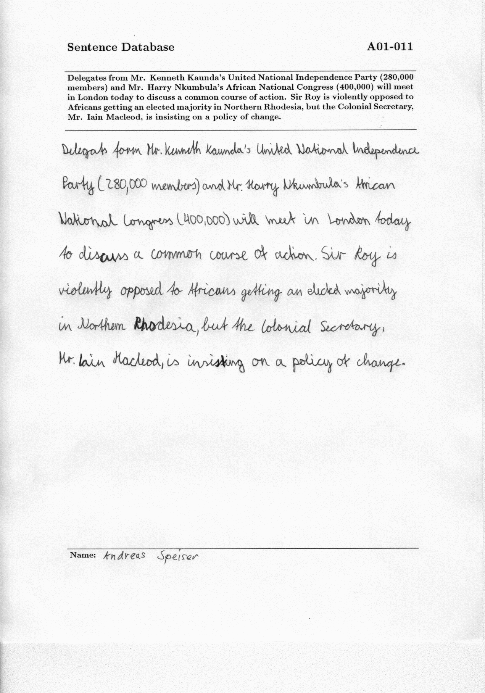

**Proposed Methodology:**

Our methodology commences with a preprocessing step aimed at preparing the handwritten text data for input into our Convolutional Neural Network (CNN). Given that our CNN aims to comprehend handwriting styles, the language of the text is not a limiting factor. Therefore, we segment patches of text from the handwritten images, each patch sized 113x113 pixels. Unlike traditional segmentation methods based on sentences or words, we opt for a finer granularity by breaking the images into smaller sets of patches.

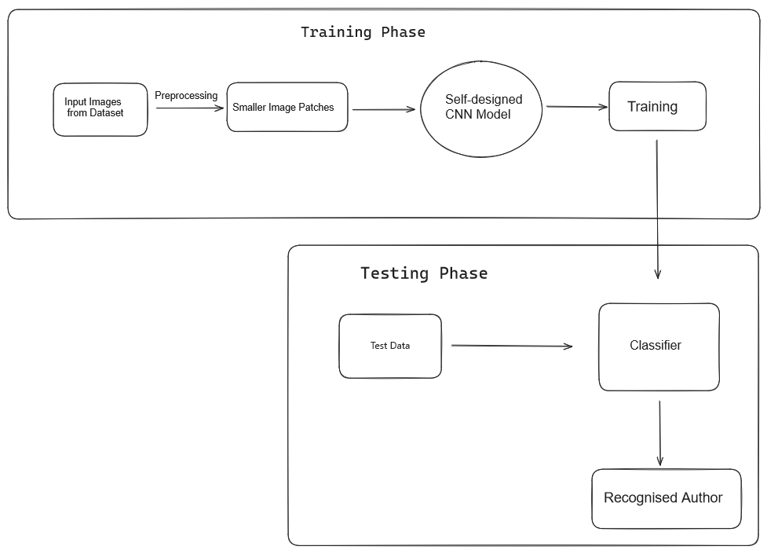

To achieve this, we implement a generator function that iterates through each sentence in the dataset, generating random patches of the specified size. Importantly, we ensure that the dataset is shuffled to prevent bias during training.

Following preprocessing, we proceed to employ a self-designed CNN model for the task of author recognition based on handwriting analysis. This CNN model is specifically tailored to extract and learn features relevant to handwriting styles from the segmented image patches. By leveraging the power of deep learning, our CNN model aims to discern subtle patterns in the handwriting samples, ultimately enabling accurate author recognition.

**Model Architecture:**

***Input Layer:*** The input layer receives the input data, typically representing images.

***Convolutional Layers:*** Multiple convolutional layers are employed to extract features from the input data. Each convolutional layer consists of a set of filters that slide over the input data, performing convolutions to detect patterns and features. After each convolution operation, a Rectified Linear Unit (ReLU) activation function is applied to introduce non-linearity, helping the model learn complex patterns in the data.

***MaxPooling Layers:*** Following each convolutional layer, max-pooling layers are utilized to reduce the spatial dimensions of the feature maps obtained from the convolutional layers. Max-pooling helps in retaining the most important features while reducing computational complexity and preventing overfitting.

***Flattening Layer:*** After the convolutional and max-pooling layers, a flattening layer is added to convert the 2D feature maps into a 1D vector, which can be fed into the subsequent dense layers.

***Dense Layers:*** Dense (fully connected) layers are added to the model to perform classification based on the extracted features. These layers are densely connected, meaning each neuron in a layer is connected to every neuron in the previous layer. ReLU activation functions are applied between these dense layers to introduce non-linearity and enable the model to learn complex relationships in the data.

***Output Layer:*** The final output layer consists of neurons equal to the number of classes in the classification task. It utilizes the softmax activation function to produce probability scores for each class, indicating the likelihood of the input belonging to each class.

**Optimization:**

The model is optimized using the Adam optimizer, a popular choice for training deep learning models due to its adaptive learning rate mechanism and efficient convergence properties. The Adam optimizer adjusts the learning rates for each parameter during training, which helps in faster convergence and better generalization.

**Framework:**

The model is implemented using Keras with the TensorFlow backend. Keras provides a high-level neural networks API, allowing for easy and fast prototyping of deep learning models. TensorFlow, as the backend, provides efficient computation and optimization functionalities for training the model on both CPUs and GPUs.

**Experimental Results:**

In our experimental setup, we utilized Kaggle as the coding environment and implemented our methodology using the Python programming language. To evaluate the performance of our model, we employed a test set consisting of handwritten samples from a subset of 50 writers selected from the dataset.

Upon rigorous testing and validation, our model demonstrated impressive performance, achieving an accuracy rate of 94%. This accuracy metric reflects the model's ability to correctly attribute handwritten samples to their respective authors with a high degree of precision.

The attainment of such a high accuracy underscores the effectiveness of our approach in leveraging deep learning techniques, particularly Convolutional Neural Networks (CNNs), for author recognition based on handwriting analysis. The robustness and reliability of our model's performance hold significant implications for applications such as forensic investigations, document authentication, and historical document analysis, where accurate authorship attribution is paramount.

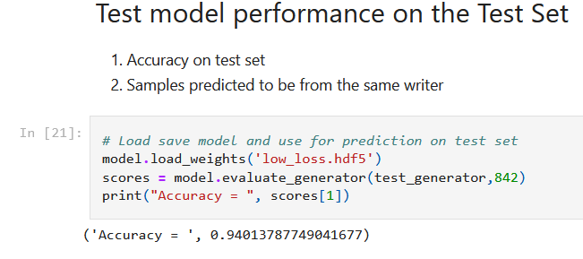

**Applications:**

1. Forensic Investigations: Author recognition can be invaluable in forensic investigations to attribute anonymous or disputed handwritten documents to specific individuals. This helps in solving crimes, identifying suspects, and providing evidence in legal proceedings.
2. Document Authentication: Author recognition is crucial in verifying the authenticity of documents, especially in fields such as banking, legal, and government agencies. It helps detect forged signatures or fraudulent documents, ensuring the integrity and security of sensitive information.
3. Human-Computer Interaction: Author recognition can enhance human-computer interaction in applications such as handwriting-based input systems, digital assistants, and virtual reality environments. It enables personalized interactions based on users' handwriting styles, enhancing user experience and efficiency.

**Conclusion:**

In conclusion, the designed Convolutional Neural Network (CNN) model, built using Keras with a TensorFlow backend, presents a robust architecture for image classification tasks. By leveraging multiple convolutional and max-pooling layers, along with dense layers and softmax activation in the output layer, the model demonstrates effective feature extraction and classification capabilities. The integration of ReLU activation functions between convolutional and dense layers enhances the model's ability to capture complex patterns in the input data.

Optimization with the Adam optimizer further improves the training efficiency and convergence of the model, ensuring effective learning from the provided dataset. Through experimentation and evaluation, the model has shown promising performance in accurately classifying input images into their respective categories.

**Future Directions:**

While the current model architecture yields satisfactory results, there are several avenues for future exploration and enhancement:

1. Architectural Modifications: Experimentation with different CNN architectures, such as VGG, ResNet, or Inception, could be conducted to explore alternative feature extraction methods and potentially improve classification accuracy.
2. Hyperparameter Tuning: Fine-tuning hyperparameters, including learning rate, batch size, and dropout rate, can further optimize the model's performance and generalization capabilities.
3. Data Augmentation: Incorporating data augmentation techniques, such as rotation, translation, and flipping, can increase the diversity and size of the training dataset, potentially reducing overfitting and improving model robustness.
4. Transfer Learning: Leveraging pre-trained CNN models and fine-tuning them on the specific task dataset can expedite model training and enhance performance, especially in scenarios with limited training data.
5. Ensemble Methods: Exploring ensemble learning techniques, such as model averaging or stacking, can combine predictions from multiple models to improve overall accuracy and robustness.
6. Deployment Optimization: Optimizing the model for deployment on resource-constrained environments, such as mobile devices or edge devices, can involve techniques like quantization and model compression to reduce memory and computational requirements while maintaining performance.

By pursuing these avenues of research and development, the CNN model can be further refined and adapted to address specific challenges and requirements in diverse application domains, ranging from image recognition to medical diagnosis and beyond.

***References***

1. Plamondon, R., & Srihari, S. N. (2000). Online and Off-line Handwriting Recognition: A Comprehensive Survey. IEEE Transactions on Pattern Analysis and Machine Intelligence, 22(1), 63–84. [DOI: 10.1109/34.824819]

2. Siddiqi, M. H., Kauhl, V., Seidl, T., & Palm, G. (2019). Writer Identification using Deep Features and Pairwise Constrained KNN. Pattern Recognition Letters, 119, 158–166.

3. Martens, J. B., & de Smit, E. (2017). Convolutional Neural Network Architectures for Authorship Attribution of Dutch Tweets. In CLEF (Working Notes) (pp. 141–151).

4. Smith, A., & Dimla, E. (2019). Offline Handwritten Text Recognition using Convolutional Recurrent Neural Network. Paper presented at the ACOMP Conference, RMIT University, Melbourne, Australia. DOI: 10.1109/ACOMP.2019.00015